Operant conditioning – type of learning that occurs when the likelihood of an organism repeating a behavior is influenced by the outcome of that behavior.

Negative reinforcement- when an undesirable stimulus is removed, which encourages a behavior to happen again.

Classical conditioning- when a stimulus that did not previously elicit a meaningful response takes on the properties of a biologically arousing stimulus.

Unconditioned stimuli cause unconditioned responses (innate reactions).

Sensory memory- auditory (echoic): few seconds

Visual (iconic): less then a second

Short term memory

Duration ~ 20 seconds

Capacity: 7 +/- 2 items

Long term memory

Duration: lifetime

Capacity: unlimited

Explicit / declarative memory -

Episodic: experiences, events

Semantic: facts, concepts

Implicit / nondeclarative memory

Procedural: skills & tasks

Emotional/ reflexive

Operant conditioning: principles of training new behavior

1) increase motivational state

2) shaping

3) continuous reinforcement

Master status- social status positions that maybe be ascribed or achieved statuses. Master status is significant that it dominates in social situations.

Intersectionality approach describes how all individuals hold multiple interconnected identities that simultaneously impact their lives and perspectives. Ex being female is not the only identity that affects how a woman sees, experiences or is treated in the world. her experiences and perspectives are also a product of her other identities e.g. – race/ ethnicity, class, sexual orientation.

Schizophrenia symptoms

Positive (pathological excesses)

Hallucinations: false sensory perception (e.g., hearing voices) in the absence of stimuli   
Delusions: false beliefs (e.g., the neighbors are aliens) despite evidence to the contrary   
disorganized/incoherent speech   
disorganized/ agitated behavior

Negative (pathological deficits)  
apathy: a lack of motivation  
social withdrawal  
flat affect: emotional flattening/ monotone speech  
poverty (lack of speech)   
anhedonia: inability to experience pleasure

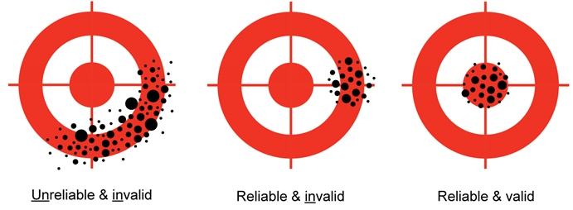

Validity- accuracy of a study or a measure.

Internal validity- extent to which a measure or experiment produces a true result.

External validity- generalizability to which study results can be applied outside the laboratory to real-life situations.

Review null hypothesis.

Alternative hypothesis – based on prior evidence and assumes that a significant relationship or difference exists between variables (often able to predict the nature of the relationship or difference).

Null hypothesis- there is no significant difference or relationship between the variables measured.

|  |  |  |  |
| --- | --- | --- | --- |
|  | Erikson’s sages of psychosocial development |  |  |
| Stage | age | Conflict | Successful resolution |
| 1) infancy | 0-1 | Trust vs. mistrust | Ability to have faith in others |
| 2) early childhood | 1-3 | Autonomy vs. shame / doubt | Sense of self-control & independence |
| 3) play age | 3-6 | Initiative vs. guilt | Ability to take initiative with peers |
| 4) school age | 6-12 | Industry vs. inferiority | Sense of confidence in skills & abilities |
| 5) adolescence | 12-20 | Identity vs. confusion | Sense of self-identity |
| 6) early adulthood | 20-40 | Intimacy vs. isolation | Ability to commit to & love others |
| 7) middle age | 40-65 | Generativity vs. stagnation | Concern for others & society |
| 8) old age | >65 | Integrity vs. despair | Sense of accomplishment & fulfillment |

Associative learning: classical conditioning

Before acquisition unconditioned stimulus (UCS) == unconditioned response (UCR)  
(response is innate) cytotoxic medication == eg. N/V, fatigue

During acquisition   
(learning)  
unconditioned stimulus + neutral stimulus (NS) == unconditioned response (UCR)  
eg. cytotoxic medication + eg. Sight of chemotherapy == eg. N/V, fatigue   
 equipment

After acquisition   
(response is learned)

Conditioned stimulus (CS) == Conditioned response (CR)  
 eg. Sight of chemotherapy == eg. N/V, fatigue   
 equipment

Functionalism: manifest vs. latent functions  
manifest functions Latent functions  
intended, obvious purpose of a social structure Unintended result of a social structure   
(eg. Teaching facts and skill is a manifest function of the (eg. Contributing to social inequality is a   
educational system) latent function of the Educ system)

Major sociological approaches to aging

Activity- remaining physically & socially active improves quality of life for older adults  
Continuity- Older adults attempt to maintain the habits & behaviors from their youth  
Disengagement- Older adults withdrawal from social relationships/ society as society withdraws from them  
Life Course- aging viewed holistically in terms of social, biological, cultural & psychological contexts

Parallel processing- the brain’s ability to process several different components of a stimulus simultaneously. For visual stimuli, the brain processes information about color, shape/form, motion, and distance (depth) separately but at the same time, so perception is seamlessly integrated.   
parvo pathway - color and form  
magno pathway- motion and depth

|  |  |  |  |  |
| --- | --- | --- | --- | --- |
|  | Mechanoreceptor | Chemoreceptor | Thermoreceptor | Photoreceptor |
| Detects | Movement | Chemicals | Temperature | Light waves |
| Stimuli | Sound waves, touch | Molecules, solutes | Heat, cold | Visible light |
| Example | Hair cells (ear) | Taste buds (tongue) | Skin | Rods, cones (retina) |

Sensory receptors are specialized neurons that detect stimuli in the internal (eg. Blood pressure) or external environment and transmit the information to the brain for interpretation and perception. The major types of receptors are mechanoreceptors, thermoreceptors, and photoreceptors.

Paiget’s theory of cognitive development

|  |  |  |  |
| --- | --- | --- | --- |
| Age (years) | Stage | Description | Developmental hallmarks |
| <2 | Sensorimotor | Experiencing the environment via senses & actions | Object permanence  Stranger anxiety |
| ~2-7 | Preoperational | Representing real things with words & images | Pretend play  Egocentrism  Language development |
| ~7-11 | Concrete operational | Thinking logically about concrete events  Grasping concrete analogies  Performing arithmetic | Conservation  Mathematical transformation |
| >12 | Formal operational | Thinking about hypothetical scenarios  Grasping abstract thoughts | Abstract logic  Moral reasoning develops |

During the sensorimotor stage (age ~0-2). Infants explore the world using their senses (eg, touch) and motor movements (eg, grabbing). After obtaining the development milestone object permanence (awareness that something still exists even when out of view, a child will search for people or objects that are out of sight, such as a parent or a toy.   
  
During the preoperational stage (age ~2-7). Children engage in pretend play, and the ability to use language emerges. However, the child is unable to assume the point of view of another person (egocentrism). For example, when asked what his mom’s favorite color is, a young boy will often report his own favorite color.

During the formal operations stage (~12+), children learn to think about abstract concepts and principles. For example, they are able to ponder hypothetical questions (eg, what would happen if I don’t complete my homework?) and generate multiple possible outcomes (eg. My mom might get upset, I might get a bad grade).

Adaptive value refers to the extent which a trait or behavior helps an organism survive and reproduce. Traits and behaviors that are innate are genetically determined. Example – babies born with many reflexes like suckling and rooting which are preprogrammed behaviors meant to help them survive.

Bottom-up processing starts with sensory input and builds up to a final perception in the brain.

Top-down processing involves prior knowledge and expectations influencing perception.

Auditory processing includes all the activities involved in the brain that recognize and interpret sound stimuli. Eg the brain perceives the amplitude of sound waves as loudness and the frequency of the sound wave as pitch; the brain perceives the source of the sound by comparing the difference between the arrival time and intensity of the sound hitting the two ears.

Place theory – explains the perception of sound pitch (how high or low a tone is). Inside the cochlea, specific sound wavelengths generate basilar membrane vibrations at specific loci. Each membrane are activated by high frequency sounds, and hair cells located at the apex of the basilar membrane are activated by low frequency sounds.

Occipital lobe contains multiple visual cortices and responsible for processing visual information from the eyes, including color, shape and motion.

Temporal lobe contains multiple auditory cortices and involved in hearing, selective listening, language processing and memory.

Right hemisphere is crucial for processing visuospatial patterns such as in a Corsi block-tapping tasks, deficits in visuospatial processing are indicative of damage to the right hemisphere. The right hemisphere is also important for artistic and musical abilities, visualization and emotion.

The mirror neuron system is utilized in with immediate recall, delayed recall, and distractor tasks.

During a Crosi block-tapping task, the experimenter touches a sequence of blocks. The subject must then recall the exact sequence performed by the experimenter after either no delay or a short (5-25 second +) delay, during which the subject performs a distractor task. The subject must hold the information in short term memory, which has a duration of 15-30 seconds. Corsi block-tapping task is a measure of visuospatial short-term memory.

Retroactive interference occurs when more recently learned information interferes with the learning of older information.

Proactive interference occurs when older information interferes with the recall of newer information.

The limbic system is a network of brain regions involved in emotion, learning, and memory. The limbic system includes the amygdala, hippocampus, hypothalamus and cingulate gyrus.

The hypothalamus regulates the pituitary gland and the autonomic nervous system. It controls the release of hormones that maintain homeostatic functions parasympathetic “rest-and-digest” response) or prepare the body to respond to a stressor (sympathetic “fight-or-flight” response). The hypothalamus is responsible primarily for the physiological component of emotion, such as changes in heart or respiration rate.

Test 1

Q1: In operant condition, reinforcement increases the likelihood of a behavior will occur again. Positive reinforcement involves the application of a desirable stimulus, whereas negative reinforcement involves the withdrawal of an undesirable stimulus.

Q3: Unconditioned stimuli (eg. Food) are biologically arousing causing an innate (untrained) reaction called an unconditioned response (eg. Salivation). Neutral stimuli (eg. Bell) do not produce a meaningful response. After being paired with the unconditioned stimuli (eg. Bell) do not produce a meaningful response. After being paired with the unconditioned stimulus, the previously neutral stimulus now becomes the conditioned stimulus, causes the organism to react with a learned or conditioned, response (eg. Salivation in response to a bell.)

Q5: implicit / nondeclarative memory is memory for things that cannot be consciously recalled, such as skills, tasks, emotions and reflexes. Classically conditioned responses rely on implicit memory.

Q9: a continuous reinforcement schedule provides a reward after every desired behavior is most effective for training an animal to perform a new behavior. Shaping (ie, rewarding successive approximations of the desired behavior) is often needed initially, Depriving an animal of the reward (eg. Food) prior to training heightens its motivation, making training easier.

Q18: Schizophrenia is a psychotic disorder characterized by positive symptoms (eg. Hallucinations, delusions, incoherent speech) and negative symptoms (eg, apathy, emotional flattening, social withdrawal).

Q20: validity refers to the accuracy of a measure or experiment (eg, a` test accurately assesses what it was designed to measure). Reliability describes the degree to which a measure or experiment is consistent eg (a test produces a similar score for one person who takes it twice).

Q21:the null hypothesis states that no significant difference or relationship exists between variables, whereas the alternative hypothesis assumes that a significant relationship or difference does exist between variables.

Q24: in operant conditioning, the outcomes of a behavior impacts the likelihood that the behavior will be repeated; behavior increases due to reinforcement and it decreases due to punishment. Positive reinforcement refers to a desirable stimulus being applied, whereas negative reinforcement is an undesirable stimulus being withdrawn.

Q25: taste aversion is a specific and powerful type of classical conditioning that occurs after just one instance of becoming ill following food/beverage consumption. Taste aversions are long lasting and can develop despite many hours passing between consumption and illness.   
  
Q28: when random assignment to conditions is not possible, researchers may use a correlational study design in which predictor variables may be assessed for their association with outcome variables. Correlational designs do not allow for the determination of causal relationships.

Q30: Structural functionalism is a macro-level sociological perspective proposing that social institutions work together to maintain societal balance (dynamic equilibrium (. Social institutions have manifest (intended) functions and latent (unintended) functions.   
  
Q31: The division of labor refers to the specialization of employment into interdependent jobs. The division of labor has positive consequences (eg, increased specialization, efficiency, reduced costs and negative consequences (eg, labor exploitation, increased boredom, reduced quality).

Q32: intersectionality suggests that for each individual, multiple social identities (eg, gender ,age, race, class) interest to impact one’s life, perspective and treatment by others in society.

Q34: Feminist theory explains differences in power between males/masculinity and females/femininity (gender inequality). Feminist theory examines both macro-level impacts of social structures as well as micro-level factors such as individual prejudice and discrimination.   
  
Q35: Top-down processing is guided by ideas, beliefs, and expectations from prior experience. Bottom-up processing is guided by sensory input.

Q36:Threshold refers to the strength of a stimulus required to detect its presence of a change in its intensity. The absolute threshold is the smallest value of a stimulus intensity at which the stimulus will be detectable 50% of the time.

Q39: Overlapping confidence intervals indicate that the difference between groups may or may not be statistically significant.

Q40: migration patterns track the movement of people from one country to another. people tend to emigrate from (leave) poorer countries and immigrate (relocate) to wealthier countries. Push factors (eg, war) drive emigration, whereas pull factors (eg, economic opportunity) drive immigration. Migration, fertility (birth) rate and mortality (death) rate impact the size and demographics of a population.

Q42: Locus of control (LOC) refers to an individual’s beliefs about who or what controls the outcome of a situation: Either a person has the ability to influence outcomes of events (internal LOC), or outcomes are determined by luck, fate, or powerful others (external LOC). Post-traumatic stress disorder (PTSD) can arise after exposure to a traumatic event and is characterized by hyperarousal, intrusive symptoms, avoidance behaviors, and negative thoughts/mood.

Q43: Interactionist theory of language development suggests that language is acquired through a process that is both social and biological. Children require interaction with caregivers early in life to learn language (social), but they are also predisposed to learn language in a way that is different from how they learn all other skills (biological).

Q44: Marriage is an official union between two adults conferring legal and social rights. Divorce is an official dissolution of a marriage. Role conflict occurs when expectations for two simultaneously held social roles compete, producing tension.

Q46: Humanistic psychology takes an optimistic approach, emphasizing the positive and relative aspects of human nature. It asserts that individuals strive toward self-actualization (fullest potential) and personal growth.

Q48: External validity, also known as generalizability is the extent to which study results can be applied to other situations or people.

Q49: Appraisal theory states that one’s evaluation of a stimulus determines one’s emotional response. In a primary appraisal, an individual determines whether a stimulus is a threat, positive, or irrelevant. If it is deemed a threat, the individual evaluates whether their resources are sufficient to cope with the stressor in the secondary appraisal.   
  
Q50: A subculture is distinct from the dominant culture but is still aligned with the general norms and values of the dominant culture.   
  
Q53: Religious affiliation describes an individual identifying with a specific religious group, whereas religiosity (or religiousness) is the degree to which an individual internalizes and incorporates that religion into their lives as demonstrated by the individual’s behaviors and beliefs.

Q56: George Herbert Mead proposed that identity formation is the result of social interactions, particularly with significant others, early in life. During the preparatory stage, babies/toddlers imitate others without comprehension. During the play stage, children begin understanding the perspectives if specific others (role-taking). During the game stage, children begin understanding the perspectives of others in society (generalized other) and social interaction rules.

Q59:Ethnography scientifically studies individual’s in their own communities to learn about culture, norms, and values within an area. Qualitative methods (eg, observation, interviews) are best for studying human social phenomena.

Test 2

Q2: The dependency ratio is the ratio of the number of dependents (people age 0- 14 and 65+) to the number of productive members in society, given as a rough estimate. The higher the dependency ratio, the more pressure there is on working-age members of society to support dependents.

Q5: A population pyramid is a type of bar graph that depicts the number or percentage of men and women in certain age brackets in a given population. Expanding pyramids show more young than old, stationary pyramids show stable populations, and contracting pyramids reflect gradually declining populations.

Q7: Attribution biases are common errors in thinking that occur when people attempt to explain behavior (their own or someone else’s). Can be dispositional, based on internal characteristics- personality, or situational, based on external factors- environment. The actor-observer bias occurs when individuals attribute their own behavior to external factors but attribute the behavior of others to internal factors.

Q10: Schizophrenia is a psychotic disorder characterized by positive symptoms (ie. Hallucinations, delusions, disorganized speech) and negative symptoms (eg. Apathy, emotional flattening). Schizophrenia is often treated with either neuroleptic or atypical antipsychotics both are generally effective in reducing positive symptoms, but neuroleptics have a greater risk of side effects (eg, sedation, psychomotor disturbances).

Q13: According to Piaget’s theory, children progress through four stages of cognitive development, based on their approximate age: the sensorimotor stage from birth to age 2, the preoperational stage from age 2 to 7, the concrete operational stage from age 7 to 12, and the stage of formal operations from age 12 to adulthood.

Q14: the adaptive value of traits refers to the extent to which a trait or behavior aids survival and/or reproduction. Innate behaviors are genetically determined. Learned behaviors result from observation and experience. Most human behaviors are complex, falling along a continuum from innate to learned.

Q15: Place theory states that specific wavelength frequencies generate vibrations at specific loci on the basilar membrane of the cochlea. Hair cells located at the base of the basilar membrane are activated by high frequency sounds, and hair cells located at the apex of the basilar membrane are activated by low frequency sounds.

Q16: The occipital lobe, located at the back of the brain- is responsible for processing visual information. The temporal lobe, located at either side of the brain – is responsible for hearing, language, processing and memory.

Q18: Hemispheric laterization is the specification of each brain hemisphere for certain cognitive functions. The right hemisphere is specialized for visuospatial, emotional, and artistic/musical processing. The left hemisphere is specialized for linguist can analytic processing.

Q19: Mirror neurons are specialized neurons that fire both while observing and performing a behavior. Mirror neurons are hypothesized to play a central role in observational learning.

Q20: proactive interference occurs when previously learned information interferes with the learning of new information. Retroactive interference occurs when more recent information interferes with the recall of previously learned information.   
  
Q21: not sure

Q22: matching ensures that only the independent variable has an effect on the dependent variable. Subjects may be matched for biological factors (eg, age, gender, IQ) but it is harder to control for environmental factors, such as stress, chemicals, and social factors.

Q24: Social loafing occurs when individuals expend less effort as part of a group than they would if working alone. The extent to which social loafing occurs is influenced by various factors, such as group size, motivation or interest in the group task.

Q26: the bystander effect predicts that that as the number of onlookers increases, the probability of an onlooker helping someone in need decreases. Partially explained by the diffusion of responsibility whereby onlookers assume action will be taken by someone else.

Q31: 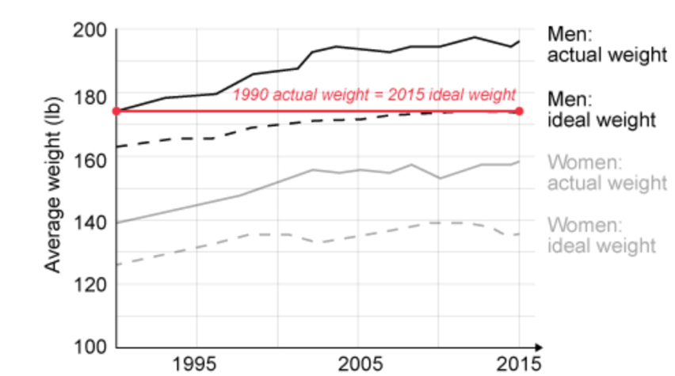

In this graph American men on average actually weighed about 176 lb in 1990 and reported an ideal weight of 176 lb in 2015. The average American man’s ideal weight in 2015 was approximately the same as his actual weight in 1990.

Q33: 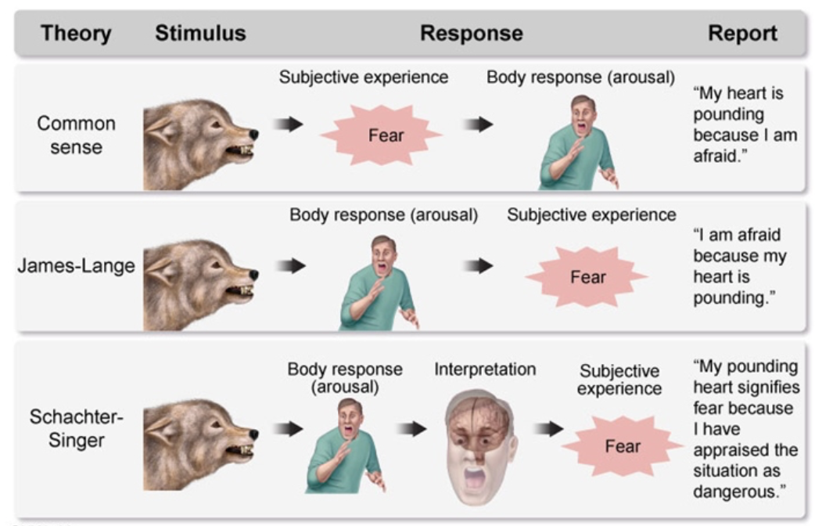

James- Lange theory suggest that specific physiological responses (eg, racing heart, sweating) produce specific emotions (eg, fear).

Commonsense view of emotion suggests that emotion (eg fear) causes physiological responses (eg, racing heart, sweating).

Q34: the limbic system comprises the amygdala, hippocampus, hypothalamus, and cingulate gyrus and is responsible for emotion, learning and memory. The hypothalamus influences the physiological component of emotion by regulating the pituitary gland and the autonomic nervous system.

Q37: Feminist theory is a macro-and micro-level sociological perspective that attempts to explain the differences in power between men and women (gender inequality) that occur as a result of discriminatory and oppressive small-scale (one-on-one) interactions and large-scale social processes.

Q39: Social facilitation is a phenomenon where by the mere presence of others enhances performance on easy, well-rehearsed tasks. Social impairment occurs when the presence of others hinders performance on difficult or unfamiliar tasks. Both are partly due to the enhanced level of arousal caused by the mere presence of others.

Q43: independent variables are manipulated by the researcher whereas dependent variables are observed/ measured. Changes to the dependent variable are assumed to be caused by the independent variables.

Q44: Attribution theory suggest that individuals attempt to explain behavior using internal/ dispositional (eg, personality, ability) causes or external/ situational (eg.. environment) causes.  
  
Q51: social mobility refers to the change in social status experienced by a group or individual. It may be vertical (upward or downward) or horizontal (no change in status) and my be intragenerational (occurring over a relatively short time among members of the same generation) or intergenerational (occurring over a relatively long time among members of different generations).   
  
Q56: the role of cognition in prejudice results from the quick, unconscious categorization of people using schemas based on age, race/ ethnicity, and gender. The implicit association test (IAT) is a psychometric technique designed to measure unconscious attitudes, including prejudice (negative feelings and beliefs).

Q58: Stereotype threat occurs when an individual is made aware of a negative stereotype regarding a group with which that individual identifies, and this awareness causes the individual’s performance to suffer.